Cairo University  
Faculty of Computers and Artificial Intelligence

**CS251**

**Introduction to Software Engineering**

Money Minds

Software Requirements Specifications

Version 1.0

Loai Hataba 20230553

Abdullah Mohamed 20230231

Hossam Abdelaziz 20230121

March 2025

Contents

Team 2

Document Purpose and Audience 2

Introduction 2

Software Purpose 2

Software Scope 2

Definitions, acronyms, and abbreviations 3

Requirements 4

Functional Requirements 4

Non Functional Requirements 6

System Models 7

Use Case Model 7

Enriched User Stories 7

System Navigation Map 11

Tools 23

Ownership Report 24

# Team

|  |  |  |  |
| --- | --- | --- | --- |
| **ID** | **Name** | **Email** | **Mobile** |
| 20230553 | Loai Hataba | LoaiHataba@gmail.com | 01275397858 |
| 20230231 | Abdullah Mohamed | abdallamohammmed649@gmail.com | 01157756931 |
| 20230121 | Hossam Abdelaziz | hossamabdelaziz2295@gmail.com | 01094723054 |

**Document Purpose and Audience**

Purpose:

The purpose of this paper is to make the requirements for this software more understandable by outlining the features that the software must have in order to reduce development time and expenses.

Audience:

* Software Development Team
* Stakeholders

**Introduction**

**Software Purpose**

The purpose of the Money Minds Software is to help users set and achieve financial goals while providing guidance for better financial planning and expense management.

**Software Scope**

Money Minds Software implements a budget tracking system for individual users or even organizations, offering various functionalities for expense tracking, income management, setting financial goals, spending analysis, and budget planning. The app helps users monitor their financial activities, generate reports, and gain insights into their spending habits to make informed financial decisions.

**Definitions, acronyms, and abbreviations**

|  |  |
| --- | --- |
| Phrase | Definition |
| **Budget** | A financial plan written down to decide how much money would be spent each month on what. |
| **Income Sources** | Something that provides a regular supply of money, such as employment, investments, or real estate |
| **Expenses** | The money spent on goods, services, and obligations such as rent, bills, and groceries. |
| **Transactions** | Records of money moving in and out, including income and expenses. |
| **Financial Goals** | Goals set by users to save or spend within specific limits over a period of time. |
| **Uptime** | The percentage of time the system is operational and accessible to users. |
| **Downtime** | The period when the system is unavailable due to maintenance or issues. |
| **Scalability** | The ability of the system to handle increased numbers of users and transactions without performance degradation. |
| **Usability** | How simple it is for people to understand and use the application |
| **OWASP** | Open Web Application Security Project, a framework that defines best practices for web security. |
| **Portability** | Portability defines how a system or its element can be launched on one environment or another. |
| **Compatibility** | Compatibility defines how a system can co-exist with another system in the same environment. |
| **Reliability** | Reliability measures the ability of a piece of equipment to perform its intended function for a specific interval without failure. |
| **Maintainability** | The simplicity with which a software system or component can be updated to fix bugs, enhance functionality or other features, or adjust to a changing environment. |
| **Availability** | Availability measures the ability of a piece of equipment to be operated if needed. |

**Requirements**

**Functional Requirements**

|  |  |
| --- | --- |
| Requirement ID | Requirement State |
| FR01 | As soon as the user launches the application, a login/sign-up screen will appear. |
| FR02 | If the user chooses to log in, the application will provide a box for them to enter their username and password. |
| FR03 | If a user chooses to register, the app will provide a signup page where they can enter their personal information, including first name, last name, password, gender, country, and email address. And asking if the user would like to sync with their bank account. This registration process will enable personalized features and secure access to their financial data. |
| FR04 | The application shall provide users with three primary tabs for managing their finances:   1. **“**My Budget” tab where users can:    * Create a new budget by specifying income sources, expense categories, and budget limits.    * Edit or delete existing budgets.    * View a summary of their financial status, including total income, total expenses, and remaining budget. 2. **“**Transactions” tab where users can:    * Add new transactions by entering details such as category, amount, date, and payment method.    * Edit or delete recorded transactions.    * Filter transactions by date, category, or amount. 3. “Goals” tab where users can:  * View their financial goals * Set new financial goals by specifying target savings, timeframes, and desired spending limits. * Track progress toward their financial goals based on their recorded transactions. |
| FR05 | In addition to the three primary tabs, the application should provide a Reports panel where users can:   1. View graphical representations (charts, graphs) of their spending and savings trends. 2. Generate summary reports of monthly or yearly income and expenses. 3. Export reports in PDF or Excel format for external use. |
| FR06 | The application should provide notifications to help users stay on track with their financial goals:   1. Budget Alerts: Notify users when they are approaching or exceeding their budget. 2. Bill Reminders: Send reminders for upcoming bills and due payments. 3. Goal Progress Notifications: Notify users of their progress toward financial goals. |

**Non-Functional Requirements**

|  |  |
| --- | --- |
| **Measure** | **Details** |
| **Performance** | * The sign-in/sign-up screen should load within 3 seconds under normal network conditions. * All screens should be loaded in under 7 seconds. |
| **Scalability** | * The system must handle up to 3,000 concurrent users without performance degradation. * It should be designed to scale dynamically as the user base grows. |
| **Maintainability** | * Critical failures must be resolved within 72 hours in at least 80% of cases. * High-priority bugs should have a 75% resolution rate within three days |
| **Reliability & Availability** | * The system must have a monthly uptime of at least 90% and a monthly downtime of no more than 72 hours. |
| **Portability & Compatibility** | * The system should be cross-platform, Android, and iOS devices. * The app should be optimized for both low-end and high-end mobile devices, ensuring smooth performance. * The system should be compatible with the latest and previous two major OS for Android and iOS. * The system should operate in both online and offline modes, enabling users to access essential features such as viewing budgets and transactions offline while requiring internet access for synchronization. |
| **Security** | * Users must only access their own financial data, with role-based access control (RBAC) or permission-based restrictions in place. * Unauthorized users must not access restricted pages or perform unauthorized actions. * The system should follow OWASP security standards to prevent common web vulnerabilities. * Data must be encrypted at rest and in transitto protect user privacy to ensure privacy and security. |
| **Usability** | * The interface should be user-friendly, intuitive, and require minimal training. * The system should follow UX best practices for accessibility and ease of navigation. * The interface should provide clear navigation**,** consistent UI elements, andresponsive design for an optimal user experience across different screen sizes. |

# System Models

## Use Case Model

## A screenshot of a computer

## Enriched User Stories

* **User Story #1**

|  |  |
| --- | --- |
| **User Story ID** | US #1 |
| **User Story Name** | User Sign-up |
| **Actors** | User |
| **Description** | **As** a user  **I like** to be able to sign-up to the application  **So** that I can sign in and use its services |
| **Per condition** |  |
| **Post condition** |  |
| **Acceptance Criteria** | **Given** I’m a user and I’m on the sign-up/log-in page  **When** I click sign-up and fill in all the fields with my information and click submit  **Then** the system signs me up |

* **Scenarios**

**Normal Scenario**

|  |  |
| --- | --- |
| **Actor Action** | **System Response** |
| 1- User clicks on sign-up |  |
|  | 2- Redirect to sign-up page  3- System displays boxes to enter information |
| 3- User Fills in the boxes  4- User chooses whether they want to sync with their bank account  5- User clicks submit |  |
|  | 6- System verifies the user information   * If user chooses to sync system adds more features to user package * Else system doesn’t add certain features to user’s account |
|  | 7- System saves user info in the database |

**Exceptional Scenario**

|  |  |
| --- | --- |
| **Actor Action** | **System Response** |
| 1- User clicks on sign-up |  |
|  | 2- Redirect to sign-up page  3- System displays boxes to enter information |
| 3- User Fills in the boxes  6- User clicks submit |  |
|  | 6- System verifies the user information  7- System finds input information invalid  8- System displays “Please enter valid information.” Message |

* **Screen Design**

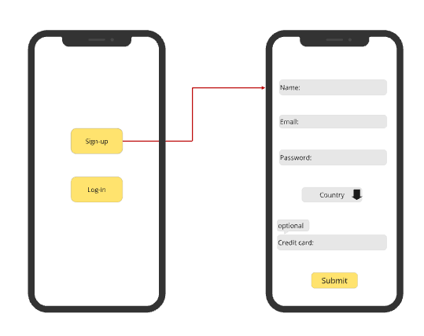

* **Data Dictionary:**

| **Element Label** | **Type/Length** | **Data Validation / Business Rule** |
| --- | --- | --- |
| Name field | Text < 50 characters | Structured Text |
| Email field | Text < 50 characters | Structured Text |
| Password field | Alphanumeric < 50 Characters | Password confirmation and must include an uppercase letter, numbers and/or special characters |
| Country field | A-Z list | Middle eastern countries only?? |
| Credit card field | Integer < 25 digits |  |

* **User Story #2**

|  |  |
| --- | --- |
| **User Story ID** | US #2 |
| **User Story Name** | User log-in |
| **Actors** | User |
| **Description** | **As** a User  **I like** to be able to log in to the application  **So** that I can use its services |
| **Per condition** |  |
| **Post condition** |  |
| **Acceptance Criteria** | **Given** I’m a logged-out user on the log-in page  **When** I fill in the “Username” and “Password” fields with my authentication credentials and I click the log-In button  **Then** the system logs me in to my account |

* **Scenarios**

**Normal Scenario**

|  |  |
| --- | --- |
| **Actor Action** | **System Response** |
| 1- User clicks on log-in |  |
|  | 2- Redirect to log-in page  3- System displays boxes to enter username and password |
| 4- User Fills in the boxes  5- User clicks log-in |  |
|  | 6- System verifies the user information |
|  | 7- System accesses user to their account |

**Exceptional Scenario**

|  |  |
| --- | --- |
| **Actor Action** | **System Response** |
| 1- User clicks on log-in |  |
|  | 2- Redirect to log-in page  3- System displays boxes to enter username and password |
| 4- User Fills in the boxes  5- User clicks log-in |  |
|  | 6- System verifies the user information  7- System finds input information invalid  8- System displays “Please enter valid username/password.” Message |

* **Screen Design**

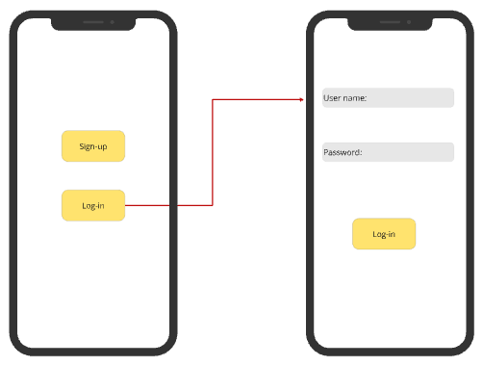

* **Data Dictionary:**

| **Element Label** | **Type/Length** | **Data Validation / Business Rule** |
| --- | --- | --- |
| Name field | Text < 50 characters | Structured Text |
| Password field | Text < 50 characters | Structured Text |

* **User Story #3**

|  |  |
| --- | --- |
| **User Story ID** | US #3 |
| **User Story Name** | Display Budgets |
| **Actors** | User |
| **Description** | **As** a User  **I like** to be able to see my budgets list  **So** that I can access a certain budget of mine |
| **Per condition** |  |
| **Post condition** |  |
| **Acceptance Criteria** | **Given** I’m a logged-in user and I’m on the home screen  **When** I click on “MyBudgets” button  **Then** the system redirects me to the Budgets list |

* **Scenarios**

**Normal Scenario**

|  |  |
| --- | --- |
| **Actor Action** | **System Response** |
| 1- User clicks on “MyBudgets” |  |
|  | 2- Redirect to Budgets page  3- System displays all of user’s Budgets and add budget button   * If user has no budgets only display add button |

* **Screen Design**

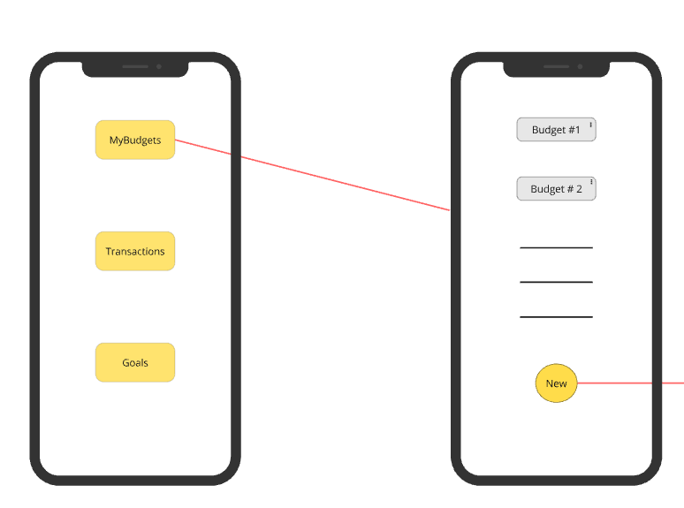

* **Data Dictionary:**

| **Element Label** | **Type/Length** | **Data Validation / Business Rule** |
| --- | --- | --- |
| Budget name fields | Text < 100 characters | Structured Text |

* **User Story #4**

|  |  |
| --- | --- |
| **User Story ID** | US #4 |
| **User Story Name** | Add/Edit a Budget |
| **Actors** | User |
| **Description** | **As** a User  **I like** to be able to add or edit a budget in my budget list  **So** that I can better manage my finances |
| **Per condition** |  |
| **Post condition** |  |
| **Acceptance Criteria** | **Given** I’m a user in the “MyBudgets” page  **When** I click on the “New” button or the 3 dots on any budget then click “Edit” and fill in the budget information fields  **Then** the system adds a budget or applies the changes to the existing budget on my budget list |

* **Scenarios**

**Normal Scenario**

|  |  |
| --- | --- |
| **Actor Action** | **System Response** |
| 1- User clicks on “New” or clicks on the 3 dots then “Edit” |  |
| 3- User clicks on “Done” button | 2 - System displays several boxes for input, including Budget name, Category, Budget income, Expenses, Budget limit, and Time frame  4- System adds the budget to the database or applies the changes to the existing budget |

**Exceptional Scenario**

|  |  |
| --- | --- |
| **Actor Action** | **System Response** |
| 1- User clicks on the 3 dots then “Delete” |  |
|  | 2- System deletes the budget from the database and from the budgets list |

* **Screen Design**

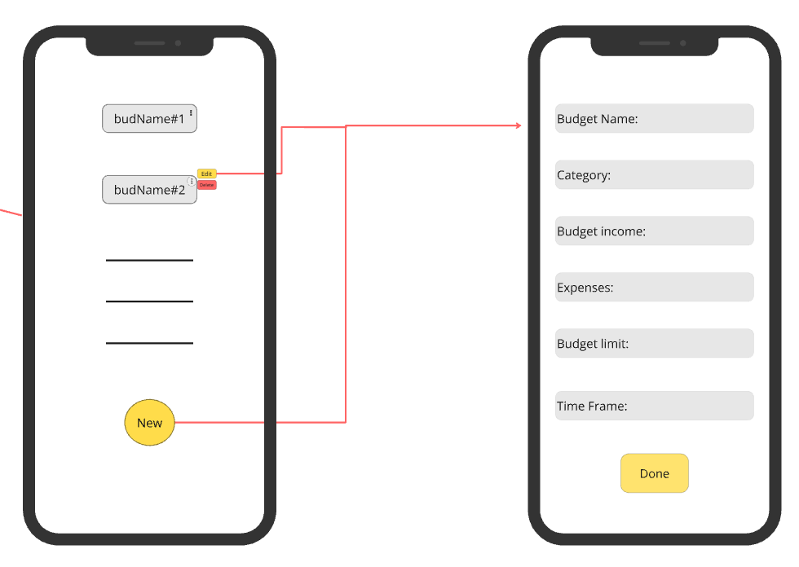

* **Data Dictionary:**

| **Element Label** | **Type/Length** | **Data Validation / Business Rule** |
| --- | --- | --- |
| Budget name field | Text < 100 characters | Structured Text |
| Category field | Text < 50 characters | Structured Text |
| Budget income field | Float < 10 digits | Only 2 digits after decimal point  and >= 0 |
| Expenses field | Float < 10 digits | Only 2 digits after decimal point  and >= 0 |
| Budget limit field | Float < 10 digits | Only 2 digits after decimal point  and >= 0 |
| Time frame field | Date/Time < 15 Characters | DD/MM/YY 24-hour format |

* **User Story #5**

|  |  |
| --- | --- |
| **User Story ID** | US #5 |
| **User Story Name** | Viewing a Budget |
| **Actors** | User |
| **Description** | **As** a user  **I like** to be able to view my budget’s details  **So** that I can track my income, expenses and remaining balance |
| **Per condition** |  |
| **Post condition** |  |
| **Acceptance Criteria** | **Given** I’m a user and I already created a budget  **When** I click on my budget title form the budget list  **Then** the system opens a detailed page of info about the budget |

* **Scenarios**

**Normal Scenario**

|  |  |
| --- | --- |
| **Actor Action** | **System Response** |
| 1- User clicks on one of their budgets on the budget list |  |
|  | 2- Redirect to that budget page  3- System displays information about the budget including summary, expenses breakdown, leftover money |

* **Screen Design**

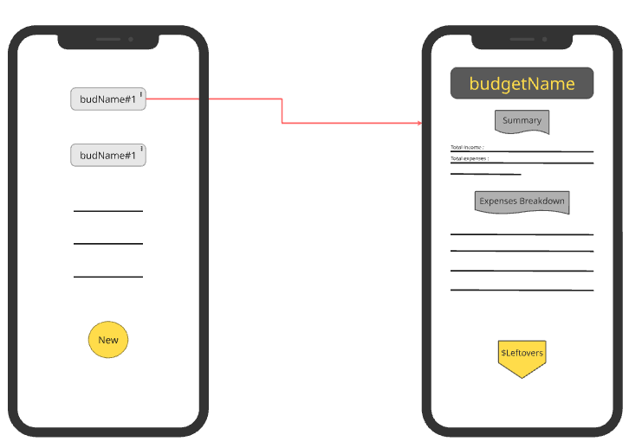

* **Data Dictionary:**

| **Element Label** | **Type/Length** | **Data Validation / Business Rule** |
| --- | --- | --- |
| Budget name field | Text < 100 characters | Structured Text |
| Summary information | Text < 1000 characters | Structured Text |
| Expenses information | Text < 1000 characters | Structured Text |
| Leftovers field | Float < 10 digits | Only 2 digits after decimal point  and >= 0 |

* **User Story #6**

|  |  |
| --- | --- |
| **User Story ID** | US #6 |
| **User Story Name** | Add/Edit a transaction |
| **Actors** | User |
| **Description** | **As** a user  **I like** to be able to see my transactions history  **So** that I can track my income and add or edit individual transactions |
| **Per condition** |  |
| **Post condition** |  |
| **Acceptance Criteria** | **Given** I’m a user and I’m on the home screen and I go to the “Transactions” page  **When** I click on “New” or the 3 dots then “edit” and fill the boxes  **Then** the system adds a new transaction or applies the changes to the existing transaction |

* **Scenarios**

**Normal Scenario**

|  |  |
| --- | --- |
| **Actor Action** | **System Response** |
| 1- User clicks on “Transactions” |  |
|  | 2- Redirect to the “Transactions” page  3- System displays the history of all transactions the user has ever made and some details about them |
| 4- User clicks on “New” or “Edit” |  |
|  | 5- System displays several boxes of input including Transaction name , Type, Category, Amount, Date and Payment Method |
| 6- User fills the boxes and clicks “Done” |  |
|  | 7- System verifies transaction information  8- System adds the transaction or saves the changes to the existing transaction in the database |

**Exceptional Scenario**

|  |  |
| --- | --- |
| **Actor Action** | **System Response** |
| 1- User fills the boxes and clicks “Done” |  |
|  | 2- System verifies transaction information  3- System finds input information invalid  4- System displays “Please enter valid information” message |

* **Screen Design**

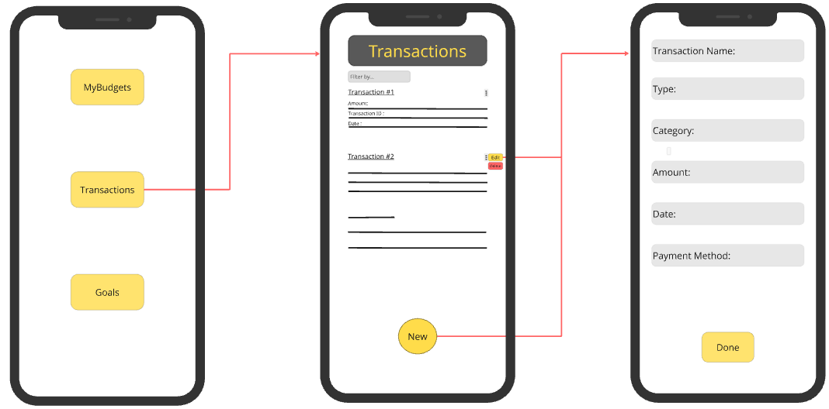

* **Data Dictionary:**

| **Element Label** | **Type/Length** | **Data Validation / Business Rule** |
| --- | --- | --- |
| Transaction name field | Text < 100 characters | Structured Text |
| Category field | Text < 50 characters | Structured Text |
| Amount field | Float < 10 digits | Only 2 digits after decimal point |
| Type field | List = 2 strings | Expense or income |
| Date field | Date/Time < 15 Characters | DD/MM/YY 24-hour format |
| Payment Method field | List < 10 strings | Payment companies supported by the application whether its card or a payment app |

* **User Story #7**

|  |  |
| --- | --- |
| **User Story ID** | US #7 |
| **User Story Name** | Reports Panel |
| **Actors** | User |
| **Description** | **As** a user  **like** to view visual reports and summaries of my income, expenses and savings  **So** that I can understand my financial habits and make informed decisions |
| **Per condition** |  |
| **Post condition** |  |
| **Acceptance Criteria** | **Given** I’m a user and I’m on the “Transactions” page and I have tracked income and expenses over time  **When** I click on “Reports” button  **Then** the system redirects me to the “Reports” page where there is visual representation of my finances so far |

* **Scenarios**

**Normal Scenario**

|  |  |
| --- | --- |
| **Actor Action** | **System Response** |
| 1- User clicks on “Reports” |  |
|  | 2- Redirect to the “Reports” page  3- System displays a Pie chart that has categories of transactions that was made by the user and a summary that has weekly, monthly and yearly expenses and income of their account |
| 4- User clicks on “New” or “Edit” |  |
|  | 5- System displays several boxes of input including Goal name, Target Amount, Time Frame |
| 6- User fills the boxes and clicks “Done” |  |
|  | 8- System adds the Goal or saves the changes to the existing Goal in the database |

**Exceptional Scenario**

|  |  |
| --- | --- |
| **Actor Action** | **System Response** |
| 1- User clicks on the export button |  |
|  | 2- System displays a choice between exporting the report as a PDF or an Excel filed |
| 3- User clicks on either way |  |
|  | 4- System downloads the file onto user’s device |

* **Screen Design**

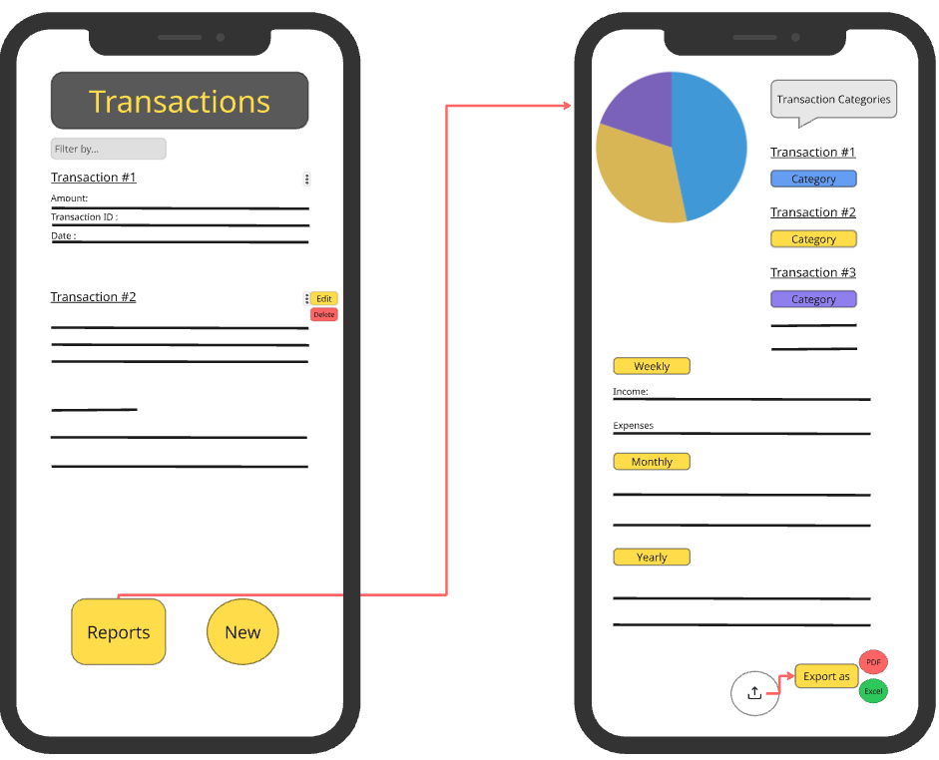

* **Data Dictionary:**

| **Element Label** | **Type/Length** | **Data Validation / Business Rule** |
| --- | --- | --- |
| Chart field | Pie |  |
| Periods Description Field | Text < 1000 characters | Structured Text |

* **User Story #8**

|  |  |
| --- | --- |
| **User Story ID** | US #8 |
| **User Story Name** | Add/Edit a Goal |
| **Actors** | User |
| **Description** | **As** a user  **I like** to be able to see and create financial goals  **So** that I can manage my savings effectively and add or edit individual Goals |
| **Per condition** |  |
| **Post condition** |  |
| **Acceptance Criteria** | **Given** I’m a user and I’m on the home screen and I go to the “Goals” page  **When** I click on “New” or the 3 dots then “edit” and fill the boxes  **Then** the system adds a new Goal or applies the changes to the existing Goal |

* **Scenarios**

**Normal Scenario**

|  |  |
| --- | --- |
| **Actor Action** | **System Response** |
| 1- User clicks on “Goals” |  |
|  | 2- Redirect to the “Goals” page  3- System displays all the financial goals that was set the user with information about them and a progress bar |
| 4- User clicks on “New” or “Edit” |  |
|  | 5- System displays several boxes of input including Goal name, Target Amount, Time Frame |
| 6- User fills the boxes and clicks “Done” |  |
|  | 8- System adds the Goal or saves the changes to the existing Goal in the database |

* **Screen Design**

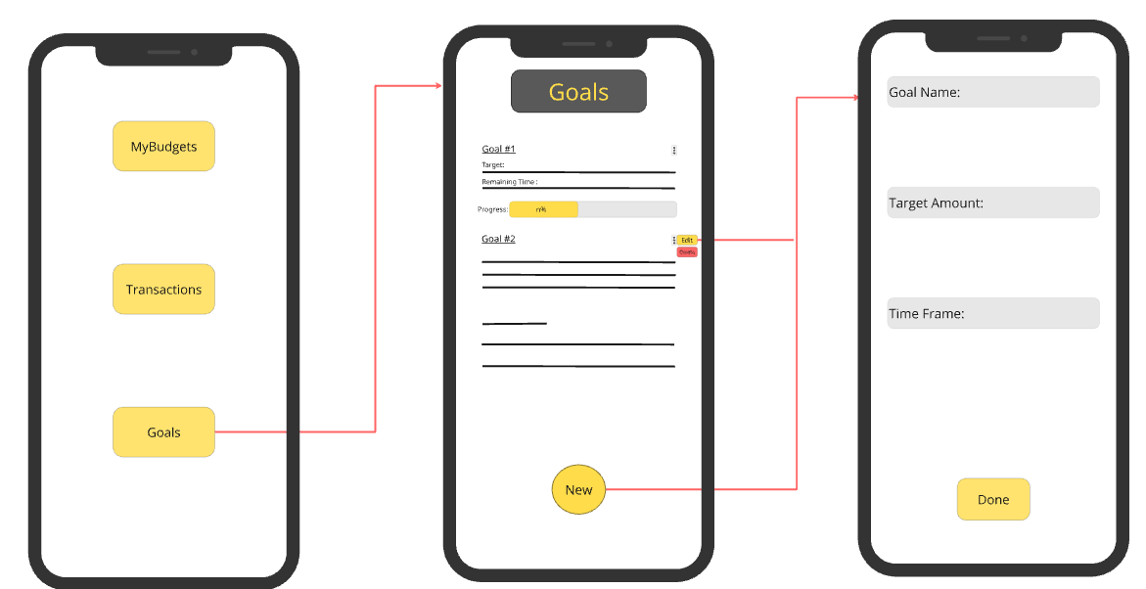

* **Data Dictionary:**

| **Element Label** | **Type/Length** | **Data Validation / Business Rule** |
| --- | --- | --- |
| Goal name field | Text < 100 characters | Structured Text |
| Target Amount field | Float < 10 digits | Only 2 digits after decimal point |
| Time Frame field | Date/Time < 15 Characters | DD/MM/YY 24-hour format |

* **User Story #9**

|  |  |
| --- | --- |
| **User Story ID** | US #9 |
| **User Story Name** | Check Transactions |
| **Actors** | Administrator |
| **Description** | **As** an Administrator  **I like** to view user’s Transactions  **So** that I can monitor the application and suspicious activities |
| **Per condition** |  |
| **Post condition** |  |
| **Acceptance Criteria** | **Given** I’m an administrator and I’m on the admin dashboard  **When** I click on a “Users” then a specific user’s account  **Then** the System redirects me to that user’s Transactions |

* **Scenarios**

**Normal Scenario**

|  |  |
| --- | --- |
| **Actor Action** | **System Response** |
| 1- Administrator clicks on “users” |  |
|  | 2- Redirect to the “Users” page  3- System displays recent users of the transactions on application and their status and emails |
| 4- Administrator clicks on a specific user’s account |  |
|  | 5- System displays user’s Transactions |
| 6- administrator decides whether to ban the user or not |  |
|  | 7- System removes the user or not according to the administrator’s decision.  8- System sends an email to the user that says their account got banned/removed |

* **Screen Design**

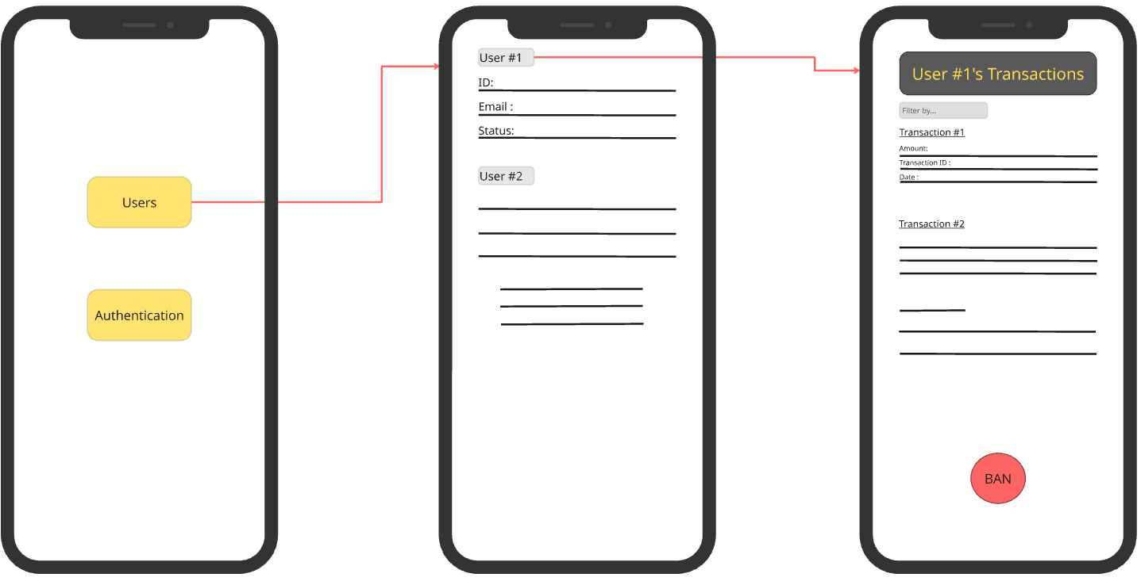

* **Data Dictionary:**

| **Element Label** | **Type/Length** | **Data Validation / Business Rule** |
| --- | --- | --- |
| User information | Text < 1000 characters | Structured Text |
| Transaction information | Text < 1000 characters | Structured Text |

* **User Story #10**

|  |  |
| --- | --- |
| **User Story ID** | US #10 |
| **User Story Name** | Authentication |
| **Actors** | Administrator |
| **Description** | **As** an Administrator  **I like** to view recent sign-ups/log-ins  **So** that I can monitor the application and validate these accounts |
| **Per condition** |  |
| **Post condition** |  |
| **Acceptance Criteria** | **Given** I’m an administrator and I’m on the admin dashboard  **When** I click on a “Authentication”  **Then** the System redirects me to recent sign-ups/log-ins on the application |

* **Scenarios**

**Normal Scenario**

|  |  |
| --- | --- |
| **Actor Action** | **System Response** |
| 1- Administrator clicks on “Authentication” |  |
|  | 2- Redirect to the “Authentication” page  3- System displays recent sign-ups/log-ins on the application |
| 4- Administrator clicks on a specific user’s account  5- Administrator validates user’s information and decides whether to ban or not |  |
|  | 6- System removes the user or not according to the administrator’s decision. |
| 6- administrator decides whether to ban the user or not |  |
|  | 7- System removes the user or not according to the administrator’s decision.  8- System sends an email to the user that says their account got banned/removed |

* **Screen Design**

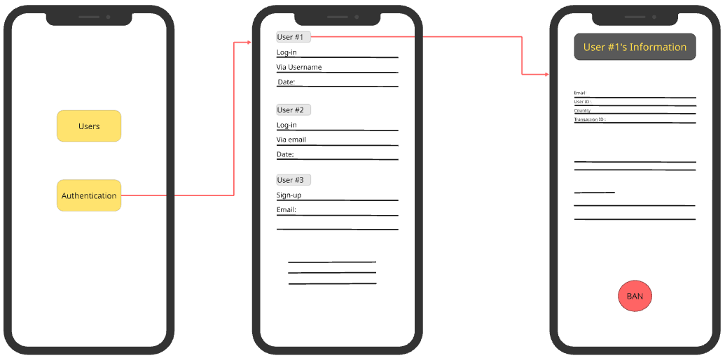

* **Data Dictionary:**

| **Element Label** | **Type/Length** | **Data Validation / Business Rule** |
| --- | --- | --- |
| User information | Text < 1000 characters | Structured Text |

## System Navigation Map

# 

# Tools

* **Write a list of all tools used to develop the design (e.g., ArgoUML, Visual-Paradigm, mocqus, etc.)**

# 

# Ownership Report

|  |  |
| --- | --- |
| **Student** | **Items he created** |
| Loai Hataba | Part of Use Case Model |
| Abdallah Mohamed | Part of Introduction, Functional and Non-Functional Requirements |
| Hossam Mohamed | Part of User Stories #1 – 10 and The Navigation map |